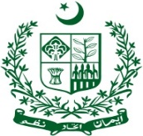
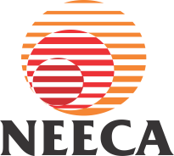
GOVERNMENT OF PAKISTAN
MINISTRY OF ENERGY (POWER DIVISION)
NATIONAL ENERGY EFFICIENCY & CONSERVATION AUTHORITY (NEECA)

Expression of Interest (EOI)
Hiring of Third Party Recruitment Firm

National Energy Efficiency & Conservation Authority (NEECA), Ministry of Energy (Power Division) is the focal agency for all energy efficiency and conservation activities in Pakistan. NEECA requires the services of a third party firm for recruitment of suitable candidates on various positions.
NEECA invites expression of interest (EOI) from interested firms of national repute for the recruitment process which includes Advertisement of the positions, Shortlisting of the applications on the prescribed criteria, Segregation of the eligible candidates and Managing/offering test centres to applicants. The firm will be hired as per the PPRA rules and following criteria will be used for shortlisting of the firms;
- Technical capability and credential for providing the recruitment services
- Preferably, experience of providing services to Federal Government institutions for hiring of highly professional and technical staff
- Profile of the key personnel involved in shortlisting of the candidates
- Firm’s legal status/registration in Pakistan
- Financial Strength and tax registration (active tax payer status)
The Academic Institutions offering programs relevant to energy sector aligned with NEECA’s mandate and professional requirements are strongly encouraged to submit EOI.
The EOI must reach at the below mentioned address in Sealed Envelops through courier, postal mail or by hand. Last date for submission of EOIs is 30th June, 2021. EOI closing time is 1600 hours. EOI shall be opened on the same day at 1630 hours. Only shortlisted firms will be offered RFP documents to submit Technical and Financial Proposals.
Administrative Officer
NATIONAL ENERGY EFFICIENCY & CONSERVATION AUTHORITY (NEECA)
NEECA Building, Sector G-5/2. Islamabad. Phone: 051-9209026

